**Time Series Lab 1**

1. **Create a scatterplot of Unemployment, Inflation and GDP for JAPAN**

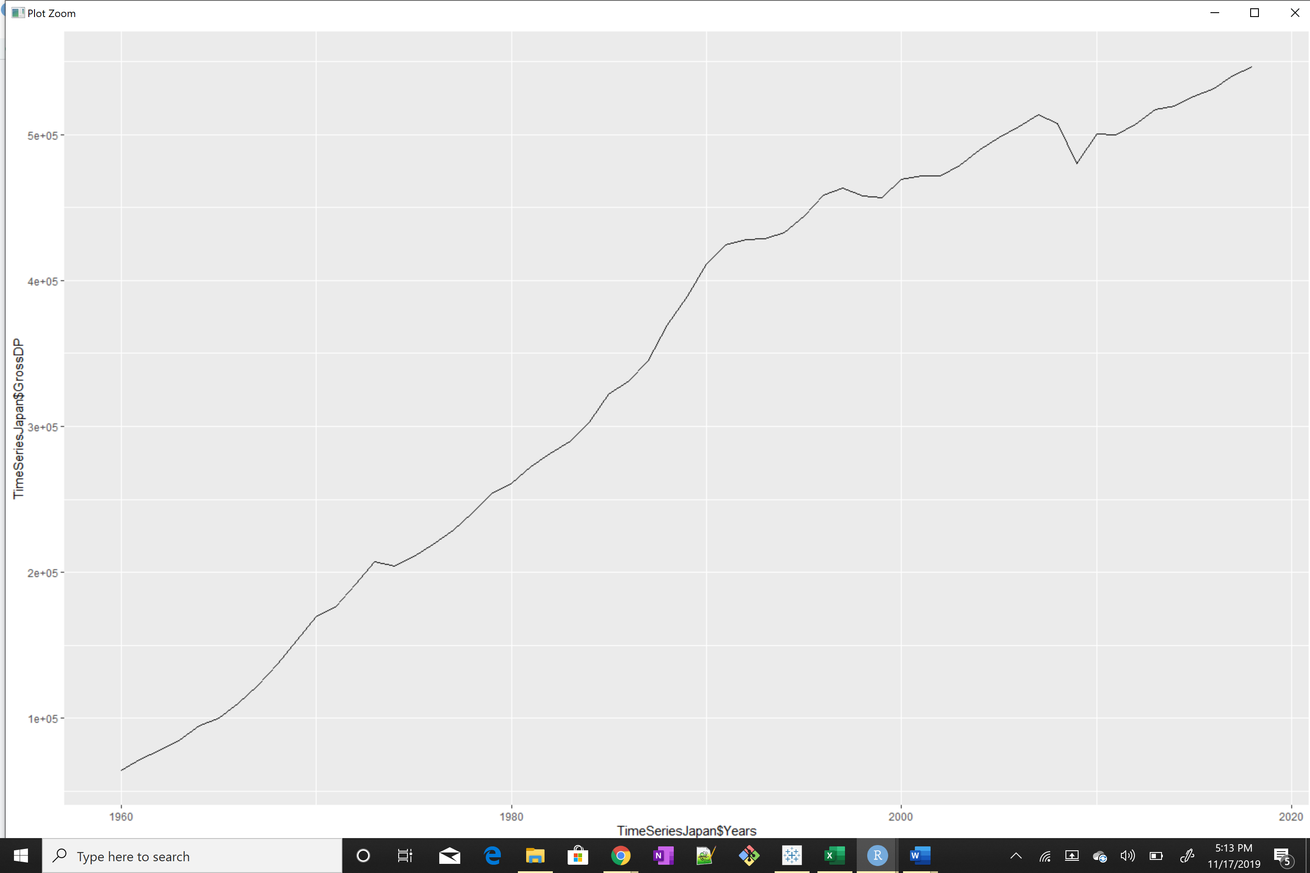

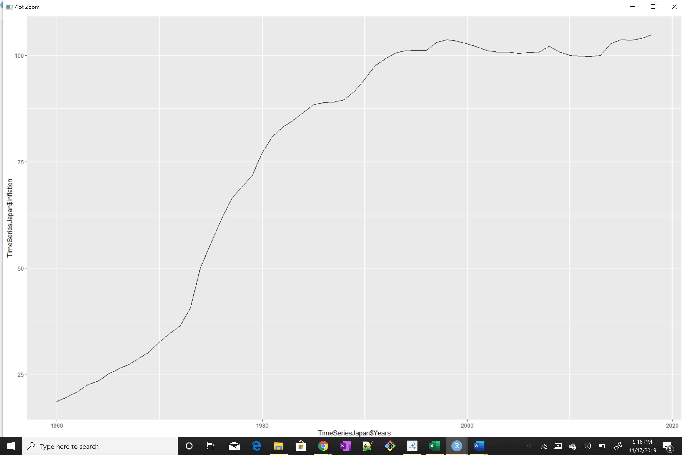

*The above GDP and Inflation graph shows Steep Inflation – it can be inferred it is not stationary still we can ADF test to conclude. If the test fails then, check if it has trend stationarity by KPSS test*

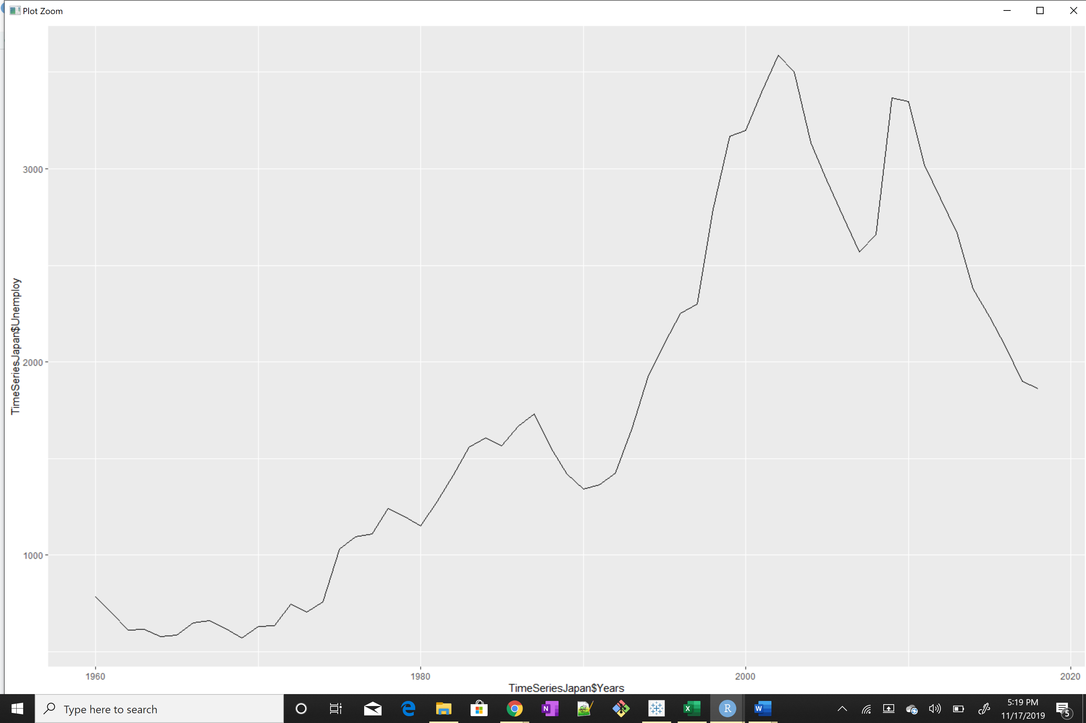

*The above Unemployment graph shows somewhat trend stationarity, this can be verified using KPSS test.*

1. **Test for stationarity in Unemployment, Inflation and GDP data**

***Augmented Dickey-Fuller Test***

data: tsGDP

Dickey-Fuller = -0.85135, Lag order = 3, p-value = 0.952

alternative hypothesis: stationary

For GDP p is not less than 0.05 so NOT STATIONARY

data: tsIF

Dickey-Fuller = -1.3968, Lag order = 3, p-value = 0.8184

alternative hypothesis: stationary

For INFLATION p is not less than 0.05 so NOT STATIONARY

data: tsUR

Dickey-Fuller = -2.0071, Lag order = 3, p-value = 0.5719

alternative hypothesis: stationary

For UNEMPLOYMENT p is not less than 0.05 so NOT STATIONARY

***KPSS Test***

***GDP and Inflation- Before Differencing:*** GDP and Inflation have p<0.05, so they cannot revert to Mean and does NOT have Trend stationarity

data: TimeSeriesJapan$GrossDP

KPSS Trend = 0.3371, Truncation lag parameter = 3, p-value = 0.01

data: TimeSeriesJapan$Inflation

KPSS Trend = 0.37625, Truncation lag parameter = 3, p-value = 0.01

***GDP and Inflation- After Differencing by 2:*** GDP and Inflation have p greater than 0.05

data: GDPdiff

KPSS Trend = 0.034139, Truncation lag parameter = 3, p-value = 0.1

KPSS Test for Trend Stationarity

data: InflDiff

KPSS Trend = 0.059051, Truncation lag parameter = 3, p-value = 0.1

***Unemployment- Without Differencing:*** Unemployment has p greater than 0.05, so they can be easily reverted to Mean and have Trend Stationarity.

data: TimeSeriesJapan$Unemploy

KPSS Trend = 0.13956, Truncation lag parameter = 3, p-value = 0.06193

1. Create the correlograms of Unemployment, Inflation and GDP data

**Unemployment:** PACF has hard cut-off and ACF trails

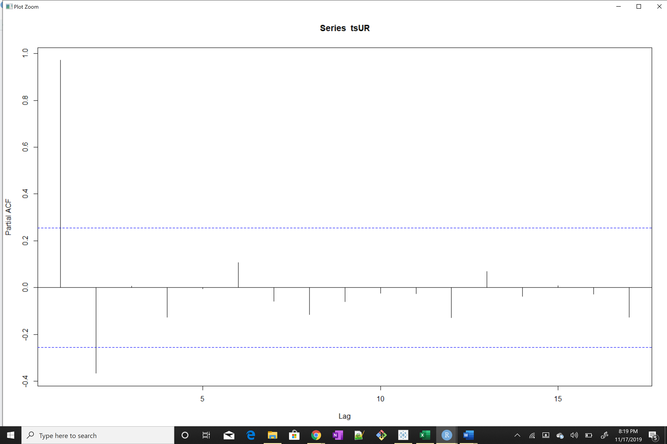

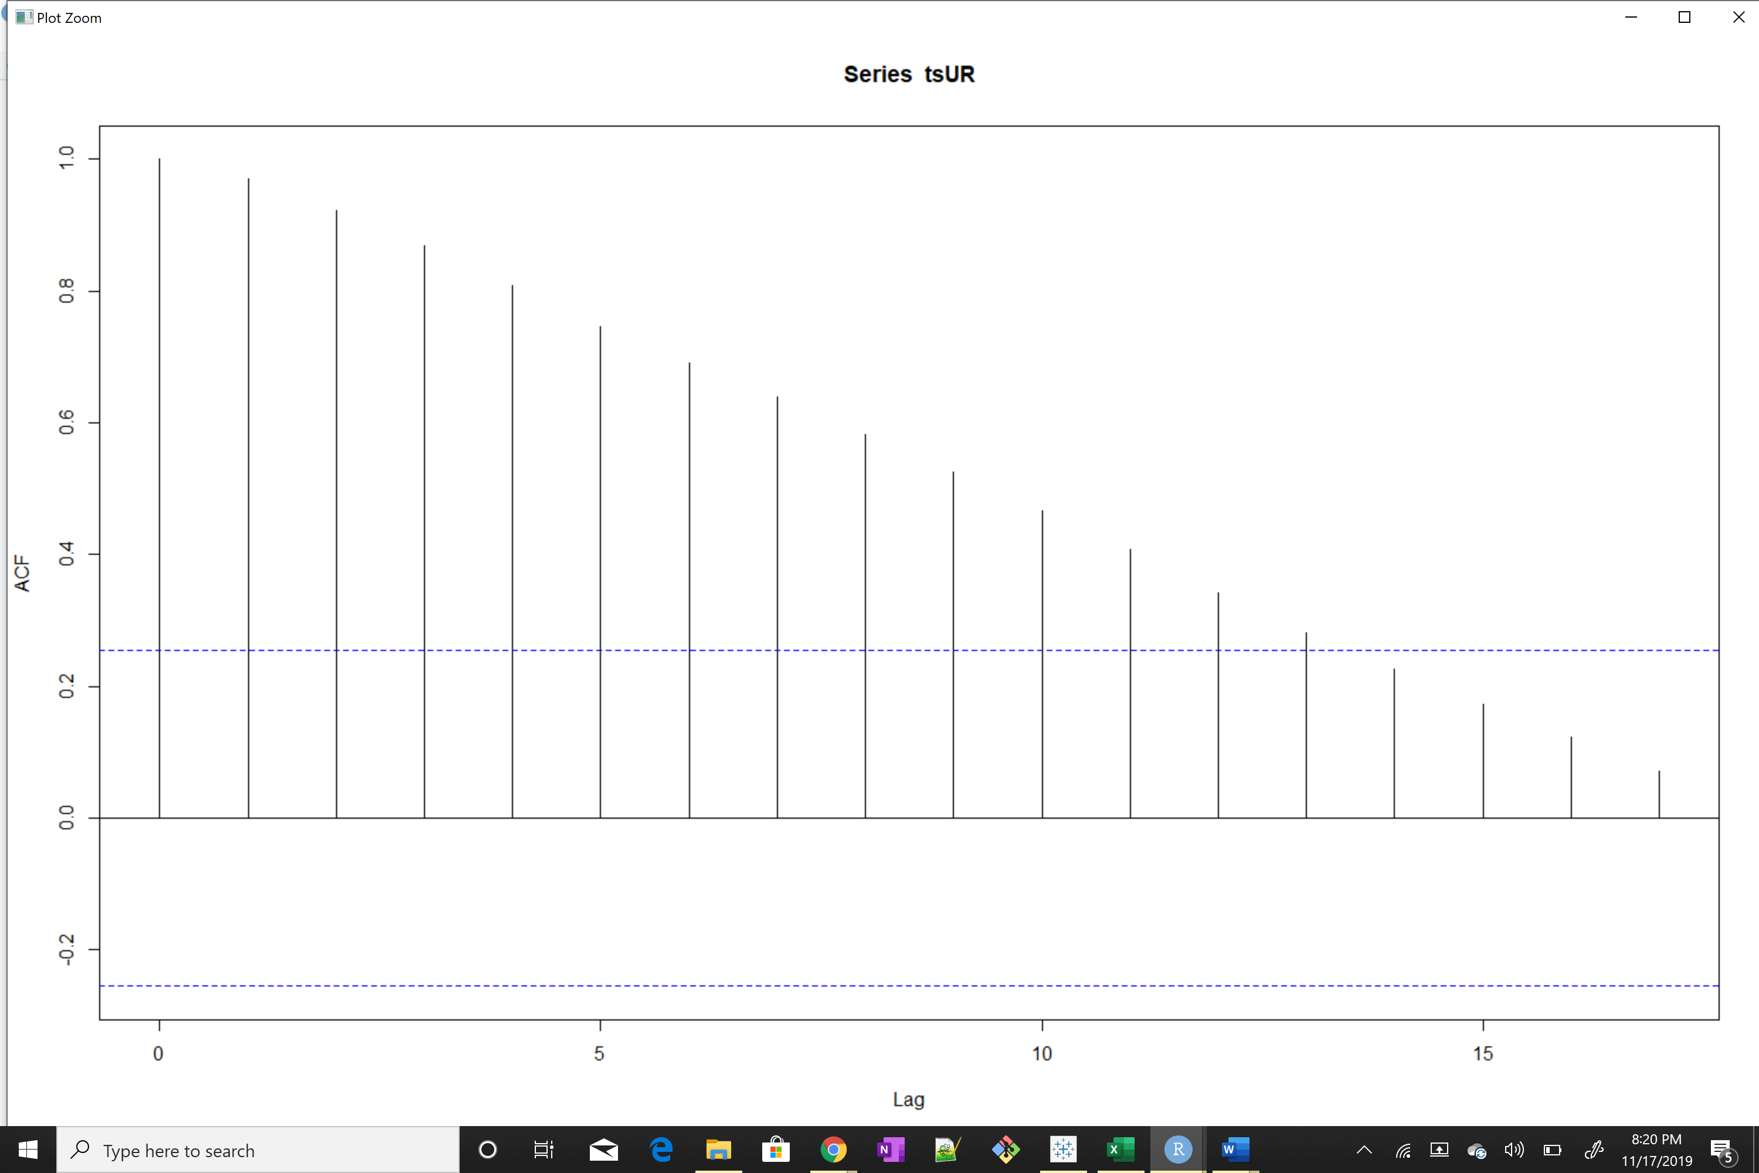

**GDP**: after differencing by 2, the PACF trails off after a lag and has a hard cut-off in the ACF after the lag.

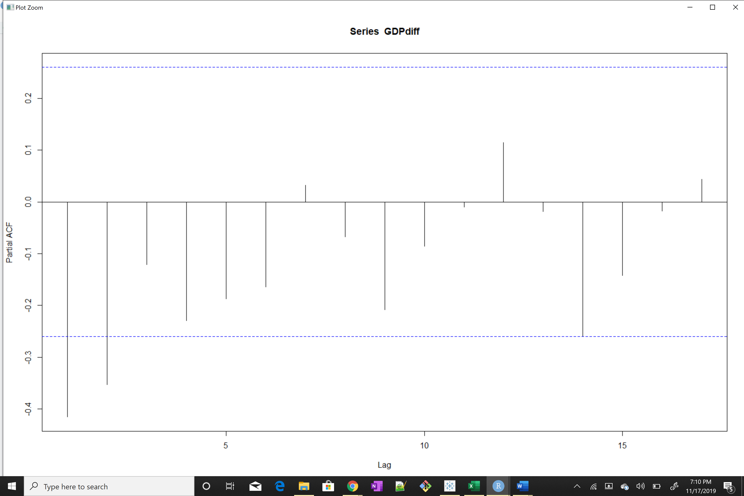

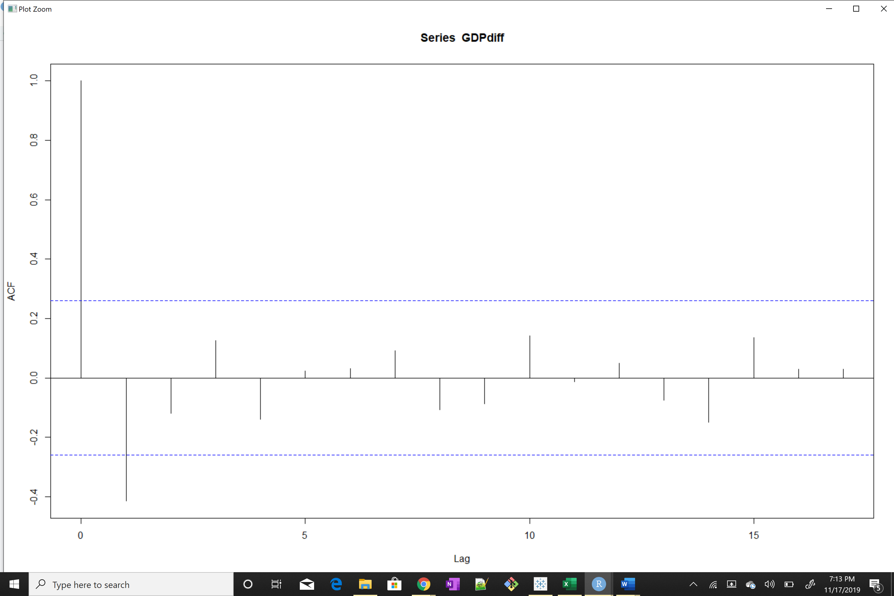

**Inflation**: after differencing by 2, the PACF and ACF has Hard Cut off

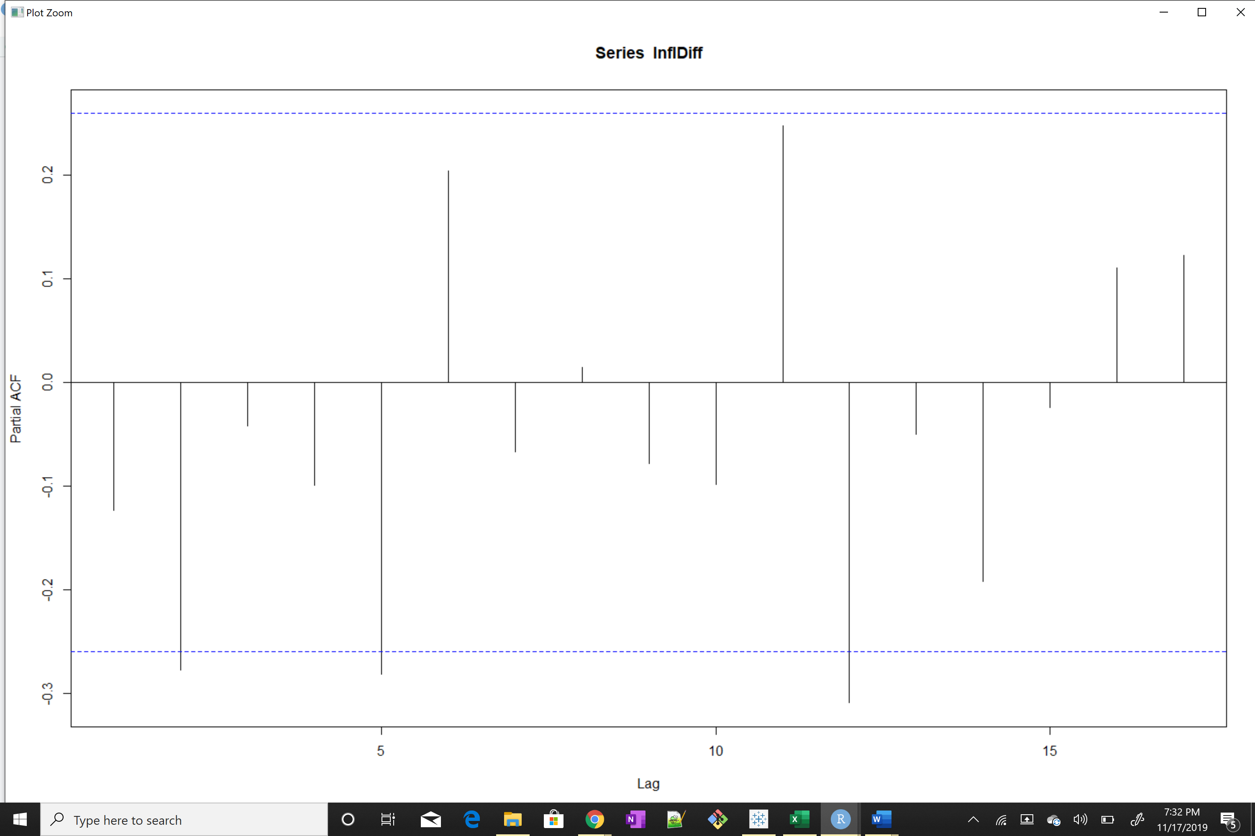

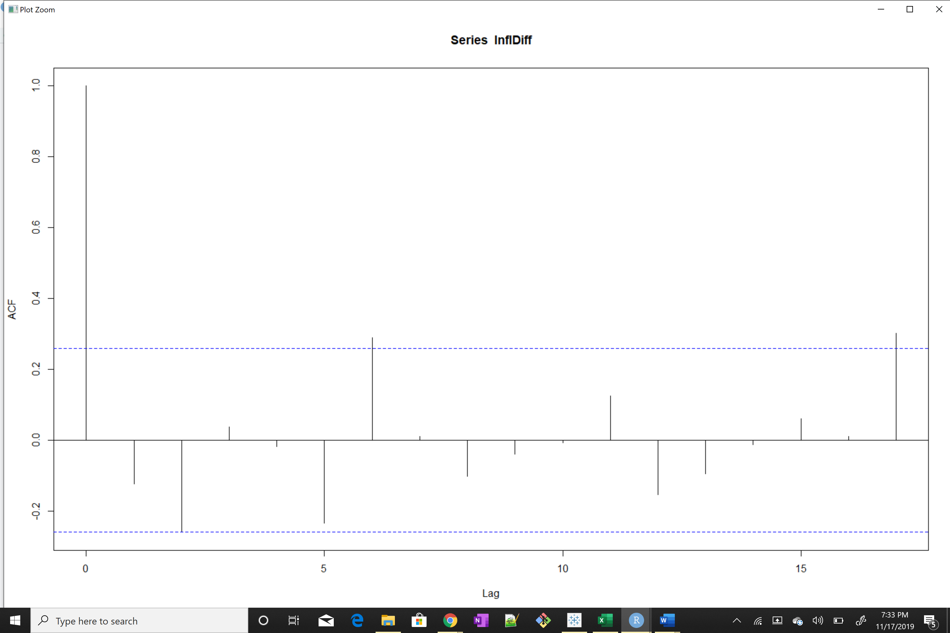

1. Model Unemployment, Inflation and GDP data using an ARMA(p) process

**Unemployment:**

ACF (*trailing*) and PACF(*Hard-cutoff*) So, AR Model (1,1,0)

Series: tsUR

ARIMA(1,1,0) with drift

Coefficients:

ar1 drift

0.4614 16.3445

s.e. 0.1149 39.3635

sigma^2 estimated as 27784: log likelihood=-378.13

AIC=762.27 AICc=762.71 BIC=768.45

**GDP:**

PACF (*Trailing*) and ACF(*Hard-cutoff having 1*) So, MA Model (0,2,1)

Series: tsGDP

ARIMA(0,2,1)

Coefficients:

ma1

-0.8495

s.e. 0.0940

sigma^2 estimated as 61367512: log likelihood=-592.09

AIC=1188.18 AICc=1188.4 BIC=1192.26

**Inflation:**

ACF and PACF(*Hard-cutoff ).* So, Mix of AR and MA Model (2,2,3)

Series: tsIF

ARIMA(2,2,3)

Coefficients:

ar1 ar2 ma1 ma2 ma3

-1.1063 -0.5673 1.0946 0.1437 -0.5278

s.e. 0.1424 0.1508 0.2678 0.3111 0.2150

sigma^2 estimated as 1.444: log likelihood=-91.03

AIC=194.05 AICc=195.73 BIC=206.31

1. Make a prediction about these data in the future, using forecast

Unemployment:

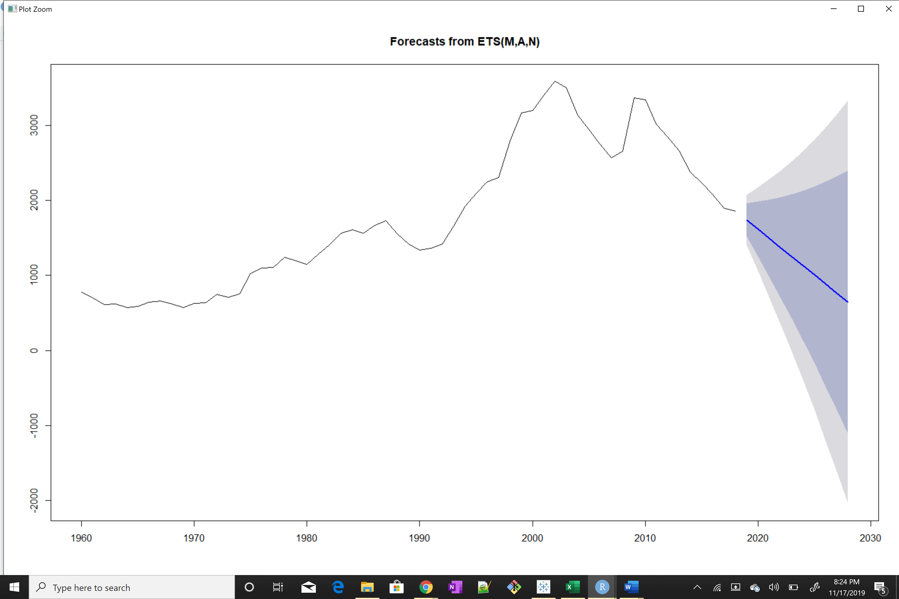

GDP:

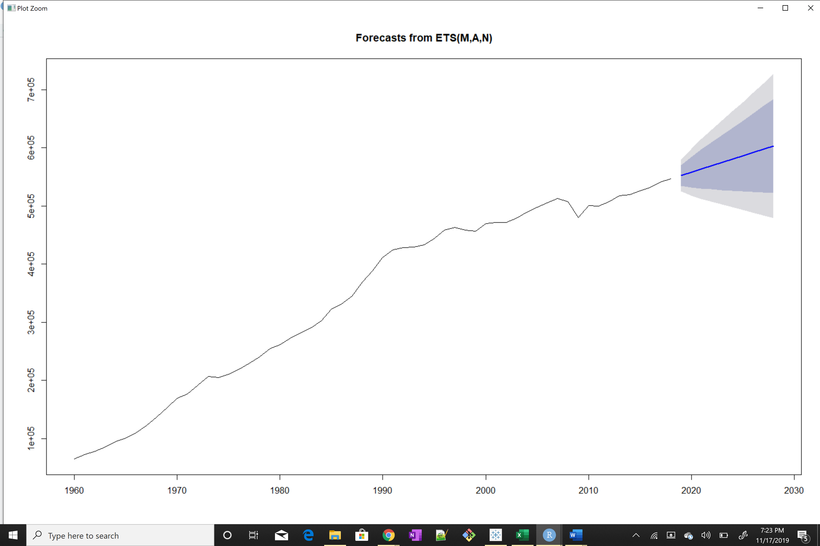

Inflation:

